Paula De Francisco Pérez  Performance Marketing · Account Management · AI-First  Dubai, UAE | +971 50 386 3656 | paulich98@hotmail.com  linkedin.com/in/paula-de-francisco-perez-92a13119a  Portfolio: paula-de-francisco.vercel.app  Nationality: Spanish | UAE Employment Visa (employer-sponsored) | 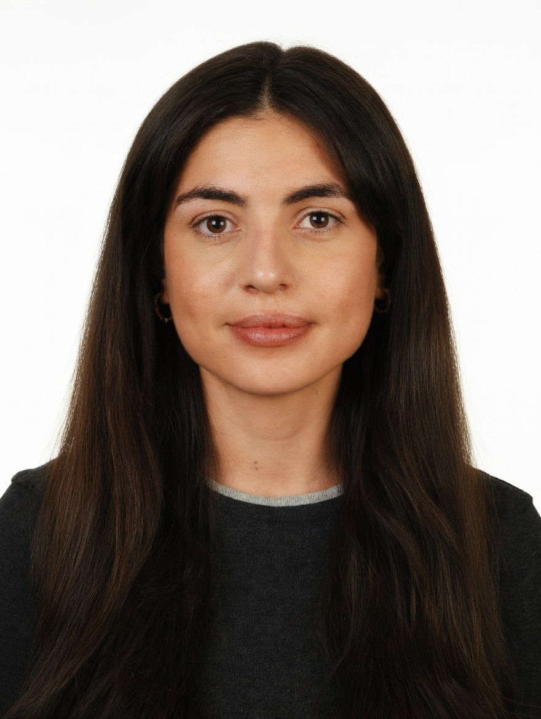
PROFESSIONAL SUMMARY

Performance marketer and account manager with 5 years across e-commerce and marketplaces. At DoFreeze, runs Meta and Google Ads against cost-per-purchase and break-even ROAS targets, plus email, creative testing and AI reporting. Before that, managed brand accounts on the platform side at Alibaba's Miravia (42 brands, +30% GMV QoQ) and Glovo (KFC, Taco Bell, Vicio).
WORK EXPERIENCE

Brand & Marketing Manager | Oct 2025 – Present
DoFreeze LLC · UAE F&B / FMCG group | 7 brands incl. Befit, Eurocake, SMASH | sold on talabat, Noon, Careem · Dubai, UAE
• Run paid social and search on Meta and Google Ads: built an Advantage+ catalogue retargeting campaign at 3.7x ROAS and AED 34.5 per purchase in week one; August account at 829K impressions, 2.01% CTR, AED 4.64 CPM
• Allocate budget across brands and channels on break-even ROAS net of marketplace commissions; moved Google spend to Meta when its return did not cover the cost
• Brief a designer and a social media exec and run weekly creative-hook tests across 4 social accounts; a SMASH giveaway added followers at AED 0.73 each, 8x cheaper than a promoted reel
• Measure incrementality, not last touch: SMASH x talabat lifted daily sales +165% vs +4.7% for a control brand; Befit x Noon added 4,176 incremental units (+31% vs baseline)
• Email and web: segmented a 16K email base for deliverability and built a 30-day replenishment flow; web orders +86%
• Built a Claude-based system that automates campaign planning, content and KPI reporting (~40% less manual work), plus landing pages built with AI agents
Key Account Manager – Beauty, Fragrances & Fashion | Nov 2023 – Oct 2025
Miravia & AliExpress (Alibaba Group) · Marketplace | Beauty & Health department · Madrid, Spain
• Managed 42 beauty and fragrance brand accounts (incl. L'Oréal Paris, Maybelline, NYX, Redken, KIKO Milano) to +30% GMV QoQ through pricing, promotions and on-site visibility; worked with marketing, product and ops
• Owned Flash Sales (up to ~30% of B&H sales), reporting to the CEO; grew Arabian perfume into a top-growing sub-category
Account Manager – XL Accounts | Sep 2022 – Nov 2023
Glovo · Food & quick-commerce delivery app | 10K+ employees · Madrid, Spain
• Co-managed 5 XL restaurant accounts (KFC, Taco Bell, Vicio) on GMV, orders, promo spend and in-app ads; read campaign returns to pick activation days
Early Career | 2019 – 2022
Mondelez International · Línea Directa Aseguradora · Global FMCG | Spanish direct insurer · Madrid, Spain
• Category Planning Trainee, Mondelez (Aug 2021 – Aug 2022): sell-in/sell-out and promo-effectiveness analysis, NPD support
• Accounting Intern, Línea Directa (Jan – Dec 2019): accounting department of an insurer, working in SAP and Looker
CORE SKILLS & TOOLS

Paid Media | Meta Ads (Advantage+, catalogue retargeting), Google Ads, budget allocation, creative testing
Digital & CRM | email & segmentation, Shopify, landing pages, SEO & AEO (schema markup), organic social
Account Mgmt | brand & partner accounts, promotions, on-site and in-app visibility, KPI targets, client reporting
Data & Analytics | ROAS, CPA, CPM, CTR, break-even ROAS, incrementality vs control, Looker, Power BI, Excel (Expert)
AI & Tools | Claude / Claude Code (AI reporting & automation), ChatGPT, Canva, Photoshop
EDUCATION

Bachelor's in Business Administration — CUNEF Universidad, Madrid | 2016 – 2020
Specialisation: E-Commerce · Fashion Industry · Thesis on e-commerce in fashion retail (9.5/10)
Google E-Commerce Certificate · Google Digital Marketing Certificate
LANGUAGES

Spanish | Native | English | Professional C1

